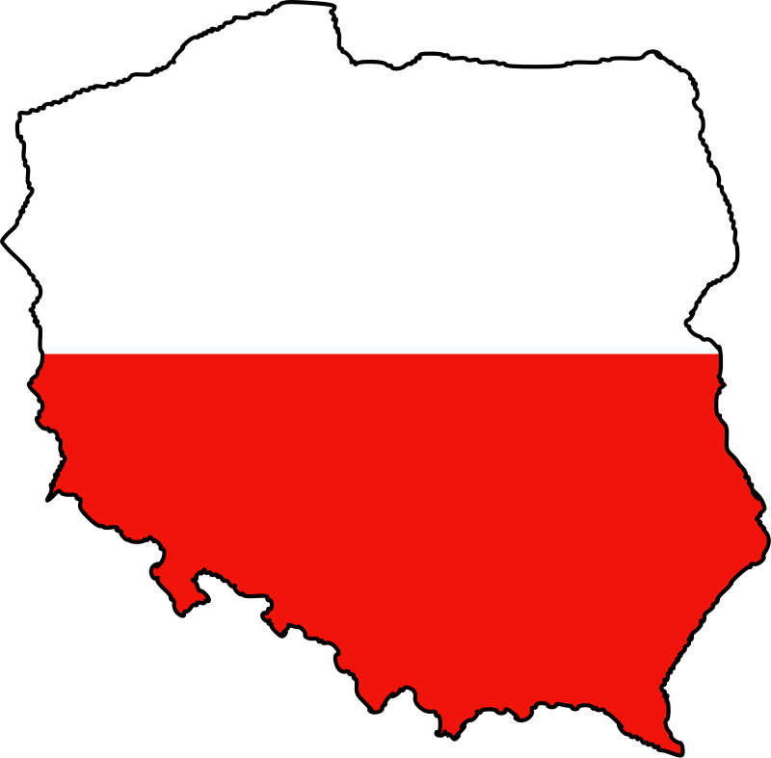
Poland - Wroclaw School of Banking

Basic information
Wroclaw is situated on the River Oder. Its population in 2011 was 631,000 people. Wroclaw is the fourth biggest city in Poland, the largest city in western Poland and the historical capital of Silesia. Wroclaw School of Banking was founded in 1998. The institution is the best non-state Business School offering Master’s degrees, according to a ranking by the “Rzeczpospolita” newspaper and “Perspektywy” 2007.

Useful links
- http://www.wsb.wroclaw.pl – School website
- http://www.wsb.wroclaw.pl/eng,wro-eng,incoming-students – Website for the incoming exchange students
- http://www.wsb.pl/english/sites/english.nowestrony.sandbox.dti.teb-akademia.pl/files/www_en/MagdaRudnicka/MZielinska/fact_sheet_2015-2016.pdf- Fact sheet 2015/2016

Transport
- City transportation - Wroclaw has an extensive tram and bus network consisting of about 25 tram lines, which mainly serve the city centre and its vicinity. Operation times are from 05:00 until 24:00 h, later there are special services of night bus lines. A student identification card and the European Youth Card Euro 26 Student entitle a student to 50% discount on public transportation (until the student reaches the age of 26). A single ticket is valid for one entrance to a bus or a tram and costs 1,40 PLN (2013). There are some possibilities to pay less with URBANCARD. For more information, please check www.urbancard.pl/en/index.html
- Travelling by airplane - Wroclaw has its international airport with direct flights from Frankfurt, Munich, Copenhagen, London, Dublin, Nottingham East Midlands, and Warsaw (more information on: http://www.airport.wroclaw.pl/en/).
- Travelling by bus – It is possible to go by bus from Prague to Wroclaw. The price varies from 400 – 690 CZK.
  - link for the bus company: https://www.elines.cz/jizdenky/CZE:Prague-POL:Wroclaw/?utm_source=adwords&utm_medium=cpc&utm_content=prague_wroclaw&utm_campaign=search_czech_cs&utm_term=praha%20wroclaw
- Travelling by train – You can also travel to Wroclaw on a direct train from Prague. The price is about 450 CZK.
  - link for the railway company – České Dráhy:
https://www.cd.cz/eshop/international/search_int_2G.aspx?tt=5

Courses and their Syllabi
You can find all courses with their syllabi on the following link:
http://www.wsb.pl/english/courses-available-in-english
Academic year 2014/2015
Winter semester
Erasmus Adaptation Days: 22.09.2014 - 26.09.2014
Lectures: 27.09.2014 - 25.01.2015
Christmas break: 22.12.2014 - 02.01.2015
Exam session: 26.01.2015 - 12.02.2015
Resit exams: 13.02.2015 - 01.03.2015

Summer semester
Erasmus Adaptation Days: 09.02.2015 – 13.02.2015
Lectures: 14.02.2015 - 21.06.2015

Easter break: 02.04.2015 - 07.04.2015

Exam session: 22.06.2015 - 05.07.2015

Resit exams: 31.08.2015 - 20.09.2015

Application and registration
Once you have been nominated to study at Wroclaw School of Banking, you are asked to send us the following documents:
- Student application form
- Learning Agreement (3 copies)
- Copy of your ID or Passport
- Copy of the European Health Insurance
- 2 original photos (45x35 mm)
http://www.wsb.pl/english/international-relations/wsb-wroclaw/llp-erasmus/incoming-students - here you can download an application form (Application procedure – Student Application Form)
Application deadlines
- Winter semester: 30th June
- Summer semester: 30th November
Documents’ Note
The completed documents should be sent to the International Relations Office by both email and ordinary post. Students who are accepted will received a confirmation of admission into the Wroclaw School of Banking.

Public holidays
1 January New Year’s Day
6 January Epiphany
variable Easter (Easter Sunday, Easter Monday)
1 May Labour Day
3 May Constitution Day
variable Pentecost Sunday (7th Sunday after Easter)
variable Corpus Christi (9th Thursday after Easter)
15 August Assumption of the Blessed Virgin Mary
1 November All Saints’ Day
11 November Independence Day
25 December Christmas Day
26 December Boxing Day

Do not forget to pack
- Passport or identity card
- Health Insurance: European Health Insurance Card + additional health insurance, if necessary
- Letter of acceptance
- 2 passport size photos
- Copies of important documents
- Debit/credit card

Accomodation
Wroclaw School of Banking doesn’t provide any accommodation for incoming students. Nevertheless, our students as buddies, support incoming students to find an accommodation and arrange their stay in Wroclaw.

Address
Fabryczna Street 29-31 (room 231, building A)
53-609 Wroclaw
phone +48 71 356 16 16
e-mail: study@wsb.wroclaw.pl

International Office

Head of International Office:
Jarosław Tomaszewski
e-mail: jaroslaw.tomaszewski@wsb.wroclaw.pl

Incoming Student Advisor:
Magdalena Zielińska
e-mail: magdalena.zielinska@wsb.wroclaw.pl

