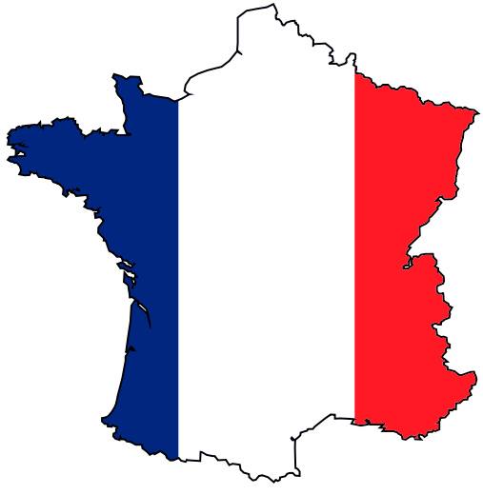
France – Groupe ESC Troyes

Basic information
The Groupe ESC Troyes was founded in 1992 and is the most recent graduate Business School in France. Troyes is located in the heart of the Champagne area, on the Seine River, about 150 kilometres southeast of Paris. Troyes is an old medieval town with the origins in the Roman Era. Many half-timbered houses mainly from the 16th century survive at the old town. Troyes is famous as the home of the Lacoste Company.
Study programmes:
- Management (ESC “Grande Ecole” Business School)
- International Business (INBA Program, School of International Management)
- Tourism, Travel and Leisure (EMVOL Program, School of International Tourism)
- Design and Applied Art (ESSA Program, School of Applied Art)

Useful links
- http://www.study-in-champagne.com/– official school website
- http://www.study-in-champagne.com/how-apply- information for international students
- http://francie.orbion.cz/stat/pruvodce/doprava-1325/ - Transport to and in France (in Czech)

Transport
- By train:
  - The SNCF (Société nacionale des chemins de fer) – France’s national state-owned railway company - http://www.voyages-sncf.com/ - you can book your ticket here
    - TGV (high speed train) - http://www.tgv.com/ (in French); from Paris to Lille in 1 hour, a seat reservation required
    - REG – SUBURBAN TRANSPORT to Paris (e.g. from the airport)
    - TER – TRAIN REGIONAL, trains within the region, each region has its special sign, a seat reservation is not usually required
- By bus – there is not any national bus company in France and long-distance bus transport is not very popular in France
  - It is possible to travel by bus (Student Agency, Eurolines) from Prague to Paris or Reims – single ticket is app. 2100 CZK
- By plane – you will probably travel to one of the airports in Paris – Charles de Gaulle, Orly or Beauvais;
  - http://www.skyscanner.cz/letistni/fr/letiste-v-francie.html - you can find the information about all airports in France where you can fly from Prague there
- Metro – metro is not only in Paris but also in Lyon, Lille, Toulouse and Marseille
  - Information about metro in Paris - http://en.wikipedia.org/wiki/Paris_M%C3%A9tro

The courses and their syllabi
You can find all courses and their syllabi on the following webpage
http://www.groupe-esc-troyes.com/index.php?option=com_wrapper&Itemid=742

Study programme Tourism – fall semester 2015/2016
http://www.groupe-esc-troyes.com/index.php?option=com_wrapper&Itemid=742
Courses in English
MTL406E01 | Management of luxury hotels | 2.5 | 2.5 ECTS
MTL407E01 | Upscale travelling and tour operators |  | 2.5 ECTS | Semester 2
MTL408E01 | Economic and environmental approach to the luxury industry |  | 2.5 ECTS | Semester 2
MTL409E01 | Management of luxury restaurants |  | 2.5 ECTS | Semester 2
MTL410E01 | Luxury event management |  | 2.5 ECTS | Semester 2
MTL412E01 | Regions & event management |  | 1.25 ECTS | Semester 2
MTL412E02 | Event management agencies |  | 1.25 ECTS | Semester 2
MTL413E01 | Hotel Management in business tourism |  | 2.5 ECTS | Semester 2
MTL414E01 | MICE tools |  | 2.5 ECTS | Semester 2
MTL415E01 | Event organization |  | 2.5 ECTS | Semester 2
MTL416E01 | Trend of business tourism |  | 2.5 ECTS | Semester 2

Academic year 2015/2016 (check Factsheet for current year)
http://www.study-in-champagne.com/sites/default/files/pdfs/factsheet.pdf - Factsheet for academic year 2015/2016

The fall semester
Arrival days 26 - 28 August 2015
A pick-up service from Troyes train station is offered only on arrival days; students are taken to their flats by ‘ESN 3’French students.
Orientation days 31 August - 2 September 2015 (compulsory)
Intensive French classes 2 - 11 September 2015
45 hours: beginner´s, intermediate and advanced levels (all French classes are free of charge)
Semester dates 1 September 2015 – 31 January 2016

The spring semester
Arrival days 1-2 February 2016
A pick-up service from Troyes train station is offered only on arrival days; students are taken to their flats by ‘ESN 3’French students.
Orientation days 3-4 February 2016 (compulsory)
Intensive French classes 5-12 February 2016
45 hours: beginner´s, intermediate and advanced levels (all French classes are free of charge)
Semester dates 1 February – 30 June 2016

Application and registration
Firstly you have to apply at your home university. If you are nominated, Groupe ESC Troyes will receive an official nomination from your home university stating that you have been selected.
Online application form (you can find link for application in Factsheet - http://www1.yes-campus.com/inscription_incomings/) is opened:
- From 15 April to 15 May for Fall and full year applications
- From 15 October to 15 November for Spring applications
Before starting to fill the online application form ensure yourself you have the following documents ready to upload - a recent passport photograph, and your passport (or ID, for European students); you should also have a printer.
When the application is completed - and once you have uploaded both documents (a recent passport photograph and a copy of your passport or ID) – print the application, sign it, have it signed and stamped by your home coordinator, and then upload it. The university will receive it automatically.
Deadline for applications
- 15 May for Fall semester
- 15 November for Spring semester

Extra documents

- Transcripts of records
- European Health card or private insurance
- Arrival form
Birth certificate + mandatory official translation into French – for CAF housing benefit

Exams
Students have to take all exams during or at the end of each semester (final exam, oral exam, report, paper work etc.). They have the possibility to re-sits (compulsory registration) once at the end of each semester.

Arrival and accommodation

Arrival
You must make sure that you let the International office know when you arrive. The International office will arrange some French students from the “International 3 Association” to meet you either at the train station in Troyes or at the School (Groupe ESC Troyes) if you come by car, and take you to your accommodation.
It is very important for the international office and all students involved in welcoming you, that you let the International office know the exact day and time you expect to arrive.
If you miss your train or if it is delayed, for example, you should phone them immediately from the train station.

Accommodation
Accommodation is organized on-line by the International Office
Online booking:
- Fall semester: 16 May - 15 June
- Spring semester: 16 November - 15 December
Rent:
- Approximately from 350 to 450 € per month per person
- 1 or 2 month-deposit requested upon arrival
- 1 or 3 month notice before departure
Once your accommodation is booked, no change will be possible.
During arrival days students will be taken to their flat, sign a 5-month (or 10-month) rental contract, pay the deposit and the first month rent and will receive the keys.

Holidays
1 January New Year’s Day
variable Easter (Good Friday, Easter Monday)
1 May May Day / Labour Day
8 May Victory in Europe Day (the end of the Second World War in Europe)
variable Ascension Day
variable Whit Monday
14 July Bastille Day
15 August Assumption of Mary to Heaven
1 November All Saints’ Day
11 November Armistice Day
25 December Christmas Day
26 December St. Stephen’s Day

Do not forget to pack
- Passport or identity card
- Health Insurance: European Health Insurance Card + additional health insurance, if necessary
- Birth certificate or other official certifications proving your nationality issued by the appropriate authorities in the country of origin, accompanied by an official translation in French (if possible) or in English

International office

Head of Department
Jean-Louis CHAPERON
Tel.: +33 325 71 22 39
E-mail: jean-louis.chaperon@get-mail.fr

Erasmus+ Coordinator for Central Europe
Laëtitia PERQUIN
Tel.: +33 325 71 22 38
E-mail: laetitia.perquin@get-mail.fr
Accommodation
Emeline LAMBERT
Tel.: +33 351 84 23 09
E-mail: emelina.lambert@get-mail.fr

