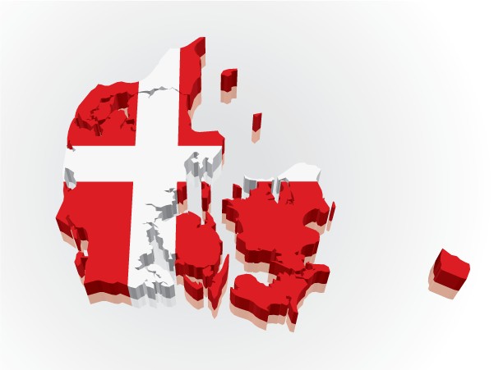
Denmark - University College of Northern Denmark

Basic information
University College of Northern Denmark is situated in the capital city of Northern Denmark – Aalborg. With more than 200 000 inhabitants Aalborg is one of the largest cities in Denmark. Since this is a university city, the number of students is approx. 40 000. As Aalborg is situated on the narrowest part of the picturesque Limfjord in the midst of wood-covered hills, moors and shallow marches, nature is ever present.
The university college has three campuses: Aalborg, Hjørring and Thisted.

Useful links
- http://www.ucnorth.dk/Home.aspx – official school webpage
- http://www.ucnorth.dk/home/programmes-courses/natural_and_cultural_heritage_management/student_in_hj%C3%B8rring.aspx Guide for incoming students
Study programme:

Natural and Cultural Heritage Management (relevant to Travel and Tourism).
http://www.ucnorth.dk/home/programmes-courses/natural_and_cultural_heritage_management.aspx

Academic year

The academic year is planned within the framework of approximately 1 September to the middle/end of June, with the following weeks free of tuition and examinations:

Summer holiday: 4 weeks

Autumn half-term holiday: 1 week

Christmas approx. 2 weeks

Spring half-term holiday: 1 week

Easter: 1 week.
+ public holidays

Application and registration
Firstly you have to apply at your home university. Application deadline: October, May
Details on application procedure for Erasmus students:
http://www.ucnorth.dk/home/programmes-courses/admission_to_ucn/admission_procedure_for_exchange_students.aspx

Deadline for registration
- 1st May for Fall semester
- 1st November for Spring semester

Official English language requirements
You may be required to present a document proving your English language proficiency.. t.

Exams
Tests and examinations are usually held at the end and in the middle of the lecture period.

Arrival
You can live in dormitory which are near school. Rent for spring semester 2015 is DKK 11,000 + a deposit of DKK 2,000.

Do not forget to pack
- Passport and identity card
- Health Insurance: European Health Insurance Card + additional health insurance, if necessary
- Birth certificate or other official certifications proving your nationality issued by the appropriate authorities in the country of origin, accompanied by an official translation in English

Residence permit

You will need a residence permit, because you are staying in Denmark for more than three months. The permit may be obtained at the State County upon arrival in Denmark. Bring your passport, two passport photos and your 'Letter of Admission' when you apply.

International office

International Student Advisor
Christina Lademann Wiederholt
Phone: + 45 72 69 06 40
E-mail: clw@ucn.dk

