Lithuania – Šiauliai State College

Basic Information:

Šiaulių valstybinė kolegija (Šiauliai State College) was established after the reorganization of two Šiauliai higher schools (medical and technical), they had long-term experience in training specialists.
Šiauliai is located in the northern part of Lithuania. The town got its name from soldiers and hunters who lived there. The whole area of the city is 81.13 sq. km. According to the area Šiauliai is the third biggest town, according to the number of inhabitants (130.020 inhabitants) it is the fourth.

Šiauliai is famous for Bubiai Mound 15 km from Šiauliai known for its wooden castle which was burnt by Crusaders, Salduve Mound which is in the Eastern part of the town. Domantai-Jurgaiciai Mound is a sacred place, its other name is the Hill of Crosses.

The town sometimes flourished, sometimes suffered from wars, plague, and fires. Today it is the largest cultural, industrial and scientific centre in Northern Lithuania.

Useful links:

Official website, information about the study programme Tourism and Hotels: https://svako.lt/en/admission-for-foreign-students
Facebook page: https://www.facebook.com/svako.lt/?fref=ts

Study programmes:

More information about the study programme: https://svako.lt/en/studies

Transport:

You can come to Lithuania by plane, train, bus, ferry or car. The main airport for international flights is in Vilnius. You can come to Šiauliai by bus (there are frequent busses from Vilnius and Kaunas), by car (A2, A9), by train (trains from Vilnius, Klaipėda, Riga, Kaunas).

Academic calendar:

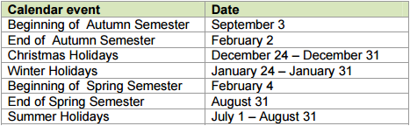
The study year consists of autumn and spring semesters. Every semester ends with a 4-week examination session.

Table of grading scale:

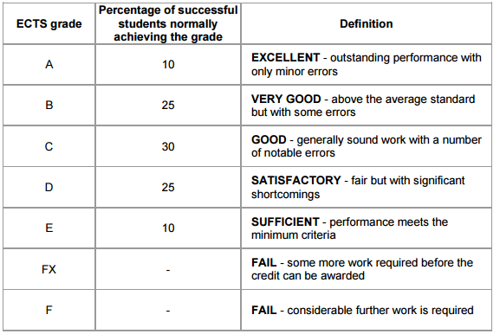
Students’ assessment - Students are tested on a course during the semester and the session. Students are examined by the subject teacher or by a department commission. Students can retake an examination for a better mark with the permission of the Dean of the Faculty.

Accomoodation:

Šiauliai State College has two Students’ Hostels. Student’s Hostels 18 and 20, Čiurlionio Street Tel. +370 41 438348, +370 41 437402
More information about the hostel - http://jnn.svako.lt/en/?lang=en

Holidays:

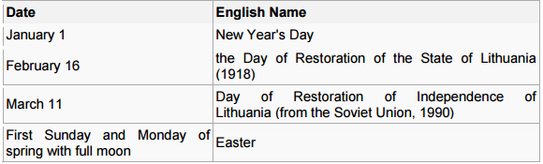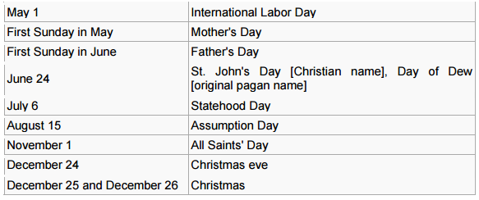

Useful information

MEALS
College has a canteen that serves an assortment of good-quality low-cost meals. It is open Monday to Friday 9 a.m. – 4 p.m.: 40, Aušros alėja. You can eat delicious food in pizzerias, canteens and cafes. There you can eat not only national dishes, but also dishes of other nationalities: http://tic.siauliai.lt/en
HEALTH CARE AND INSURANCE
International students are requested to have medical insurance valid in Lithuania for the study period (for EU citizens European Health Insurance Card).

STUDY FACILITIES
Library and self-study centre
The library is a modern information centre with direct communication to teachers, students and town society having different knowledge needs. One of the most important goals of the College library is to satisfy professional information needs of students and teachers, to foster favourable conditions for receiving study literature.
The funds of the College library consist of about 70 thousand books and periodicals. The library closely collaborates with other libraries of Lithuania. Open: Monday – Thursday 8 a.m. – 7 p.m. Friday 8 a.m. – 4 p.m.
Self-study centre of the College library is the centre of modern technologies. The goal of the centre is to provide favourable conditions to use the Internet, electronic databases, to foster IT skills. The library has joined the Lithuanian Net of Academic Libraries.
More detailed information - https://svako.lt/en/admission-for-foreign-students

Contacts

Šiaulių valstybinė kolegija (Šiauliai State College)
Aušros al. 40
LT-76241 Šiauliai
Lithuania
Phone: 370 41 52 37 68
Fax: 370 41 52 50 91
E-mail: administracija@svako.lt
Principal: Dr. Natalija Šedžiuvienė
E-mail: direktore@svako.lt
Deimantė Ubytė, Head of International Relations and Project Management Department
Phone +370 41 433793
Fax +370 41 525091
E-mail d.ubyte@svako.lt

