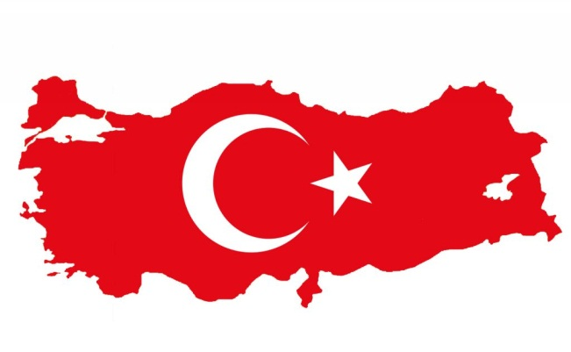
Izmir Katip Celebi University

The Izmir Katip Celebi University was founded in 2010. This university is situated in Izmir - the large metropolis in western extremity of Anatolia and the third most populous city in Turkey. The population of Izmir is about 3 402 000 inhabitants. The city of Izmir is composed of several metropolitan districts. Konak district corresponds to historical Izmir. İzmir has a Mediterranean climate which is characterized by long, hot and dry summers; and mild to cool, rainy winters. It is probably the most modern city in Turkey.

Useful links
- http://ikc.edu.tr/en/ - official university webpage
- http://disiliskiler.ikc.edu.tr/en/sayfa - international relations webpage
- http://www.turkeytravelplanner.com/trans/Bus/ - bus transportation

Transport
- By airplane – the best way how to travel to Turkey is probably by the airplane. It is possible to fly to Izmir from Vienna or Prague with one transfer
- By bus – travelling by bus is the easiest, cheapest and most popular way how to travel in Turkey; dozens of bus companies; often, buses are so frequent that you needn't reserve them in advance, except around holidays
  - link to top bus companies in Turkey http://www.turkeytravelplanner.com/trans/Bus/top_firms.html
- By train:
  - Turkish State Railways (TCDD, DDY) – the high speed trains
  - Link to the most important train routes in Turkey http://www.turkeytravelplanner.com/trans/Train/best_trains.html

- Metro:
  - Izmir has a subway network that is constantly being extended with new stations; it consist of one line (the second one is planning) with 14 stations; the length is about 16 kilometres

Holidays:
1 January New Year’s Day
23 April National Sovereignty and Children's Day
1 May Labor and Solidarity Day
19 May Commemoration of Atatürk and Youth and Sports Day
30 August Victory Day
29 October Republic Day
variable Ramadan Feast
variable Sacrifice Feast

Erasmus Coordinator
Assist. Prof. Aşkın Haluk YILDIRIM
E-mail: askin.haluk.yildirim@ikc.edu.tr

