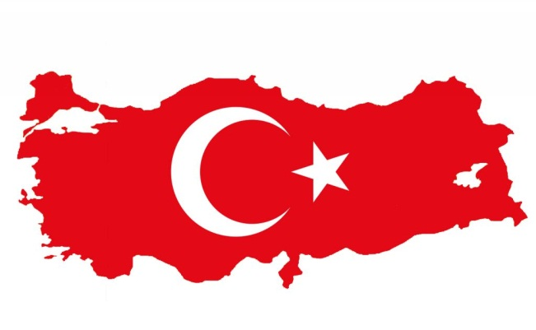
Turkey – Afyon Kocatepe University

Basic information:
Afyon Kocatepe University was founded in 1992, and started the educational activities in academic year 1992-1993. The university is located in Afyonkarahisar, a province in western Turkey, 260 kilometers far away from capital Ankara.
Faculty of Economics and Administrative Sciences

Useful links:
Official website: http://www.aku.edu.tr/anasayfa/eng/index.htm
Information for Erasmus+ students: http://www.aku.edu.tr/anasayfa/eng/erasmus.htm

Transport:
- you can go to Afyonkarahisar
  - by plane: you can fly to Istanbul or Ankara from Prague or Vienna
  - by train from Istanbul / Ankara: check the schedule on http://www.haydarpasagar.com/
  - by bus: for more information about bus connection check the information for Erasmus students at school website or contact directly the university uib@aku.edu.tr

The courses:
Please contact International Relations Office for information about the courses taught in English offered for a particular academic year or semester

Winter semester / summer semester
The academic year at the University of Economy is divided into 2 semesters – the autumn and the spring semester. Attendance of lectures is compulsory. In case of any missed class, a student has to fulfill the appropriate tasks regardless of the reason why class was missed. The time for performing the missing tasks is settled by the lecturer.

Autumn semester
The autumn semester runs from September to January.

Summer semester
The spring semester runs from February to June.
Exams:
There are two exam periods for each semester as midterm exams and final exams. Student has to attend for both exams in order to get an average score.

Application and registration:
Firstly you have to apply at your home university. If you are nominated, you have to send these documents to Afyon Kocatepe University:
- Student Application Form
- Learning Agreement
- Accommodation form

Deadline for applications:
Autumn semester: 1 August
Spring semester: 1 December

Arrival and accommodation
Erasmus+ students will receive all the necessary assistance in organizing the study process and accommodation from International Relations Office. There will be Turkish students assigned to Erasmus+ students who will help the students to feel at home in Afyonkarahisar and Turkey. All Erasmus+ students are also encouraged to participate in an orientation course on Turkish culture.

Accommodation
You will apply for accommodation using the Accommodation Form. The accommodation is provided in a youth hostel located adjacent to the main campus. The price is approximately 100 €. However you can also rent a private flat and share it with other students. Renting a flat costs 200 – 300 € (50-60€ per person).

Holidays:
1 January New Year’s Day
23 April National Sovereignty and Children's Day
1 May Labor and Solidarity Day
19 May Commemoration of Atatürk and Youth and Sports Day
30 August Victory Day
29 October Republic Day
variable Ramadan Feast
variable Sacrifice Feast

Don’t forget to pack
- Identity card and passport
- Health insurance card
- Student card
- Debit / credit card
- All necessary documents

International contact office
Afyon Kocatepe University
Address: Gazlıgol Yolu ANS Campus 03200 Afyonkarahisar
E-mail: uib@aku.edu.tr uim@aku.edu.tr
Tel.: + 90 (272) 444 03 03 /1413 (Ext.) + 90 (272) 228 13 03
Fax: +90 (272) 228 13 51

