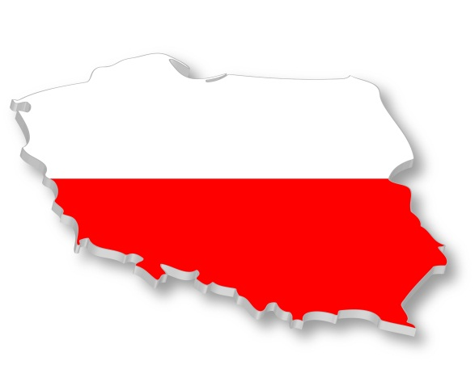
Poland – University of Rzeszow

Basic Information:
The University of Rzeszow was established in 2001 and it provides education at ten faculties. It has over 22 000 full- and part-time students. The city of Rzeszow is located in southern Poland with population almost 180 000 and it lies on both sides of the Wislok river.
Faculty of Medicine
Institute of Nursing and Health Sciences

Useful links:
Official webside: http://www.univ.rzeszow.pl/en
Information for Erasmus students: http://www.ur.edu.pl/en/university/erasmus/ects-internet

Transport:
- travelling in Poland and abroad: http://www.bilety-autobusowe.com/
- you can go to Rzeszow
  - by bus – direct buses are available (info on www.idos.cz)
  - by plane from Prague, transfer in Warsaw (LOT Polish airlines https://www.lot.com/cz/en/)

Syllabi:
- all syllabi are available here: http://www.ur.edu.pl/en/university/erasmus/sylabus-2013/nursing-14-15
NOTICE! Courses and ECTS could change in the beginning of the academic year.

Academic Year
The academic year in University of Rzeszow is divided into 2 parts – SUMMER and WINTER SEMESTER.

Winter semester takes from October 1, 2013 to February 07, 2014 and includes:
didactic classes - October 01, 2013 - December 22, 2013
winter holidays - December 23, 2013 - January 06, 2014
didactic classes - January 7, 2014 - January 26, 2014
exam period - January 27, 2014 - February 07, 2014

Winter-semester break - February 8, 2014 - February 16, 2014

Summer semester takes from February 17, 2014 to September 30, 2014 and includes:
didactic classes - February 17, 2014 – April 16, 2014
spring holidays – April17, 2014 - April 22, 2014
didactic classes - April 23, 2014 - June 08, 2014
exam period - June 09, 2014 - June 29, 2014

Summer break - June 30, 2014 - September 30, 2014

Exams:
Exams are held during two weeks right after the end of each semester.

Application and registration:
Firstly you have to apply at your home university. If you are nominated, you will fill in on-line Application Form. Make sure that you print, sign and send the application by ordinary mail as well. You also have to enclose these documents:
- 3 identity card size pictures
- photocopy of the passport or identity card
- transcript of records
- statement about good knowledge of English at least B1 level within the Common European References of Languages (signed by Institutional or Departmental Coordinator)
Students of nursing, midwifery and physiotherapy have to bring with themselves current results of examinations:
- X-ray of chest
- Carrier state testing Salmonella and Shigella
- Blood cell count determination (morfology)
- Urine analysis
- Medical examination about state health with stamp and signature of doctor
Students need also proper insurance for working in hospital

Deadline for applications:
Winter semester: 31 May
Summer semester: 31 October

Arrival and accommodation:
Contact the International office about the date and time of you arrival. The staff of the Office will pick you up at the station, introduce you to academic staff, and help you to find a student tutor who will be able to help you with some practical matters during your stay, will provide for a Polish language course and organize trips to Kraków, Wieliczka and Lańcut.

Accommodation:
Accommodation is provided in students’ hostels. Costs of living for one month are about 148 – 205 €.
The University of Rzeszów is in possession of 2800 places in students' hostels

Hostel "Laura"
35-326 Rzeszów
Cicha str. 2
tel. (+4817) 854-18-59
e-mail: dslaura@op.pl
Head: M.A. Tadeusz Marut

Hostel "Filon"
35-326 Rzeszów
Cicha str. 4
tel. (+4817) 854-18-93
Head: Izabela Winiarska

Hostel number 4
35-205 Rzeszów
Warszawska str. 26a
tel. (+4817) 853-29-99
Head: Ewa Czarnek

Hostel number 3
36-007 Krasne
Krasne 30a
tel. (+4817) 852-53-06
Head: Barbara Kunysz

Hostel "Merkury"
35-959 Rzeszów
Ćwiklińskiej str. 2b
tel. (+4817) 857-42-67
Head: Marek Ogrodniczek
Hostel "Hilton"
Ćwiklińskiej str. 2c
tel. (+4817) 857-42-65
Head: Marek Ogrodniczek

Hostel "Olimp"
Siemieńskiego str. 17
35-203 Rzeszów
tel. (+4817) 853-92-05
Head: M.A. Grażyna Taradajko

Holidays:
1 January New Year’s Day
6 January Epiphany
variable Easter (Easter Sunday, Easter Monday)
1 May Labour Day
3 May Constitution Day
variable Pentecost Sunday (7th Sunday after Easter)
variable Corpus Christi (9th Thursday after Easter)
15 August Assumption of the Blessed Virgin Mary
1 November All Saints’ Day
11 November Independence Day
25 December Christmas Day
26 December Boxing Day

Don’t forget to pack:
- Identity card and
- Health insurance card
- Student card
- Debit / credit card

International office contact:
Rejtana str. 16 c, room 26
35 - 959 Rzeszów, Poland
tel./fax.: (+48 17) 872 10 71
Opening hours: Mo and Fri 9.00 - 14.00

Lucyna Kustra - Head of International Relations Office, Coordinator for International Programmes - Incoming teachers (STA), Bilateral agreements - lkustra@ur.edu.pl
Anna Zając - Incoming students (SMS, SMP), outgoing students (SMP), outgoing teachers (STT) - dzwz@ur.edu.pl
Agnieszka Kuca - outgoing and incoming student and teachers (not-Erasmus) - akuca@ur.edu.pl

