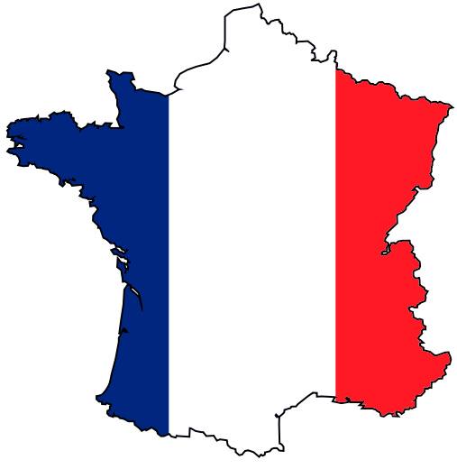
France – Groupe ESC Troyes

Basic information
The Groupe ESC Troyes is French Business School, which was founded at Troyes in 1992. Troyes is located in the heart of Champagne area, on the Seine River, about 150 kilometres southeast of Paris. Troyes has been existed since the Roman Era. Many half-timbered houses mainly from the 16th century survive at the old town. Troyes is famous as the home of the Lacoste Company.
Study programmes:
- Management (ESC “Grande Ecole” Business School)
- International Business (INBA Program, School of International Management)
- Tourism, Travel and Leisure (EMVOL Program, School of International Tourism)
- Design and Applied Art (ESSA Program, School of Applied Art)

Useful links
- http://study-in-champagne.com/our-schools – official school webpage
- http://study-in-champagne.com/how-to-apply - information for international students
- http://francie.orbion.cz/stat/pruvodce/doprava-1325/ - Transport to and in France (in Czech)
- http://study-in-champagne.com/files/pdf/factsheet.pdf - Factsheet 2014/2015 - all important information about university

Transport
- By train:
  - The SNCF (Société nacionale des chemins de fer) – France’s national state-owned railway company - http://www.voyages-sncf.com/ - you can book your ticket here
    - TGV (high speed train) - http://www.tgv.com/ (in French); from Paris to Lille in 1 hour, a seat reservation required
    - REG – SUBURBAN TRANSPORT to Paris (e.g. from the airport)
    - TER – TRAIN REGIONAL, trains within the region, each region has its special sign, a seat reservation is not usually required
- By bus – there is not any national bus company in France and long-distance bus transport is not very popular in France
  - It is possible to travel by bus (Student Agency) from Prague to Paris or Reims – single ticket is app. 2050 CZK
- By plane – you will probably travel to one of the airports in Paris – Charles de Gaulle, Orly or Beauvais;
  - http://www.skyscanner.cz/letistni/fr/letiste-v-francie.html - you can find the information about all airports in France where you can fly from Prague there
- Metro – metro is not only in Paris but also in Lyon, Lille, Toulouse and Marseille
  - Information about metro in Paris - http://en.wikipedia.org/wiki/Paris_M%C3%A9tro

The courses and their Syllabi
You can find all courses and their syllabi on the following webpage:
http://www.groupe-esc-troyes.com/index.php?option=com_wrapper&Itemid=742

Study programme Tourism – fall semester 2013/2014
Courses in English
Title | Number of hours | ECTS
English | 30 | 2,5
E-tourism | 30 | 5
Management of tourist sites | 30 | 5
Law of tourism in an international context | 15 | 2,5
Team management | 15 | 2,5
Yield management | 15 | 2,5
Food and beverage | 15 | 2,5

Courses in French
Title | Number of hours | ECTS
Sports and leisure activities of a sports – like nature | 15 | 2,5
Tourism law and regulation | 30 | 5
Financial analysis | 30 | 5
Market Survey | 15 | 2,5
Statistical analysis | 15 | 2,5
Amadeus | 15 | 2,5
Customer relations | 15 | 2,5
Tourist accommodation | 30 | 5
Development of regional tourism | 30 | 5
Economic fundamentals | 15 | 2,5
Introduction to the marketing function applied to tourism | 15 | 2,5
Consumer behaviour | 15 | 2,5
Introduction to tourism | 30 | 5
E-Tourism Law | 15 | 2,5
Management control | 30 | 5
From the idea to the project | 30 | 5
Human resources (administrative management of personnel) | 15 | 2,5
Strategic management | 30 | 5
Purchasing tourism products | 15 | 2,5
Travel agents and tour operators | 15 | 2,5
Tourist transport | 15 | 2,5

Academic year 2014/2015 (check Factsheet for current year)

The fall semester
Arrival days 28-29 August 2014
A pick-up service from Troyes train station is offered only on arrival days; students are taken to their flats by ‘ESN 3’French students.
Orientation days 1-2 September 2014 (compulsory)
Intensive French classes 3-12 September 2014
45 hours: beginner, intermediate and advanced (all French classes are free of charge)
Semester dates 1 September 2014 – 31 January 2015

The spring semester
Arrival days 2-3 February 2015
A pick-up service from Troyes train station is offered only on arrival days; students are taken to their flats by ‘ESN 3’French students.
Orientation days 4 February 2015 (compulsory)
Intensive French classes 5-13 February 2015
45 hours: beginner, intermediate and advanced (all French classes are free of charge)
Semester dates early September 2015 – 30 June 2015

Application and registration
Firstly you have to apply at your home university. If you are nominated, Groupe ESC Troyes will receive an official nomination from your home university stating that you have been selected.
Online application form (you can find link for application in Factsheet) is opened:
- From 15 April to 15 May for Fall and full year applications
- From 15 October to 15 November for Spring applications
Before starting to fill the online application form ensure yourself you have the following documents ready to be upload - a recent passport photograph, and your passport (or ID, for European students); you should also have a printer.
When the application is completed - and once you have uploaded both documents (a recent passport photograph and a copy of your passport or ID) – print the application, sign it, have it signed and stamped by your home coordinator, and then upload it. The university will receive it automatically.

Extra documents

- Transcripts of records
- European Health card or private insurance
- Arrival form
Birth certificate + mandatory official translation into French – for CAF housing benefit

Exams
Students have to take all exams during or at the end of each semester (final exam, oral exam, report, paper work etc.). They have the possibility to re-sits (compulsory registration) once at the end of each semester.

Arrival and accommodation

Arrival
You must make sure that you let the International office know when you arrive. The International office will arrange some French students from the “International 3 Association” to meet you either at the train station in Troyes or at the School (Groupe ESC Troyes) if you come by car, and take you to your accommodation.
It is very important for the international office and all students who are involved in welcoming you, that you let the International office know the exact day and time you expect to arrive.
If you miss your train or if it is delayed, for example, you should phone them immediately from the train station.

Accommodation
Accommodation is organized on-line by the International Office
Online booking:
- Fall semester: 16 May - 15 June
- Spring semester: 16 November - 15 December
Rent:
- Approximately from 350 to 450 € per month per person
- 1 or 2 month-deposit requested upon arrival
Once your accommodation is booked, no change will be possible.
During arrival days students will be taken to their flat, sign a 5-month (or 10-month) rental contract, pay the deposit and the first month of rent, will receive the keys.

Holidays
1 January New Year’s Day
variable Easter (Good Friday, Easter Monday)
1 May May Day / Labour Day
8 May Victory in Europe Day (the end of the Second World War in Europe)
variable Ascension Day
variable Whit Monday
14 July Bastille Day
15 August Assumption of Mary to Heaven
1 November All Saints’ Day
11 November Armistice Day
25 December Christmas Day
26 December St. Stephen’s Day

Do not forget to pack
- Passport or identity card
- Health Insurance: European Health Insurance Card + additional health insurance, if necessary
- Birth certificate or other official certifications proving your nationality issued by the appropriate authorities in the country of origin, accompanied by an official translation in French (if possible) or in English

International office

Head of Department
Jean-Louis CHAPERON
Tel.: +33 325 71 22 39
E-mail: jean-louis.chaperon@get-mail.fr

Erasmus+ Coordinator for Central Europe
Laëtitia PERQUIN
Tel.: +33 325 71 22 38
E-mail: laetitia.perquin@get-mail.fr
Accommodation
Emeline LAMBERT
Tel.: +33 351 84 23 09
E-mail: emelina.lambert@get-mail.fr

