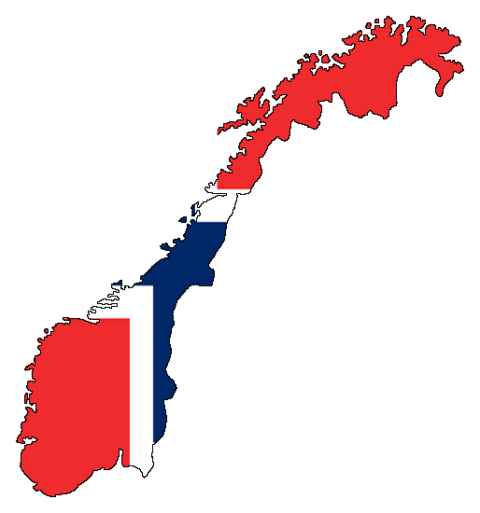
Norway - Buskerud and Vestfold University College

Basic information

Buskerud and Vestfold University College (Norwegian: Høgskolen i Buskerud og Vestfold, HBV) is a regional university college with campuses in Drammen, Kongsberg, Hønefoss and Horten in the counties of Buskerud and Vestfold, Norway. It was created as a merger of Buskerud University College and Vestfold University College on 1 January 2014. It is the second-largest university college in Norway, measured in students, after Oslo and Akershus University College.

Useful links
- http://www.hbv.no/?lang=en_GB - university website
- https://www.hbv.no/study-here/practical-information/ – student information – everything you should know before arrival

Transport
- By plane – you will probably travel to Norway by plane to Oslo and then continue to Horten by bus or to Tønsberg by train. There are also several direct flights from Prague to Oslo for a valuable price if you book it early. You can choose from two airports in Oslo which is more suitable for you.
- By bus - NOR-WAY Bussekspress' extensive coach network covers most of Norway. NOR-WAY has a seat guarantee on all bus services, which means you are guaranteed a seat without making an advance reservation.
  - link - http://www.nor-way.no/
  - Here you can find how to get from Tønsberg to Bakkenteigen
    - http://www.vkt.no/Rutetabeller.aspx
- By train - The rail transits are operated by the counties, and integrated into the bus transport.

The courses and syllabus
You can find easily all courses and their syllables on following link:
- https://www.hbv.no/academic-programmes/exchange-programmes/business-and-management/business-and-tourism/

Application and registration
Firstly you have to apply at your home university. If you are nominated, the Vestfold University College will receive an official nomination from your home university stating that you have been selected.
Application deadlines (2014/2015):
- 1st May for Autumn semester
- 1st November for Spring semester
Required documents:
- You need to send the following documents to Vestfold University College
  - Printed copy of the Application Form
  - Current transcript of records
Academic calendar:
https://www.hbv.no/students-a-z/academic-calendar-2014-2015-article81148-8035.html

Accommodation
All useful information you can find here: https://www.hbv.no/students-a-z/accommodation-article81157-8035.html

Holidays
January 1 New Year’s
variable Easter (Maundy Thursday, Good Friday, Easter Sunday, Easter Monday)
May 1 Labour Day
May 17 Constitution Day
variable Ascension Day (39 days after Easter)
variable Pentecost (49 days after Easter)
variable Whit Monday (50 days after Easter)
December 25 Christmas Day
December 26 St Stephen’s Day

Visa
Students arriving from EEA member countries do not need a residence permit to study in Norway.
! Nevertheless, if your course of study is for three months or longer, you will need to register online at UDI.no https://selfservice.udi.no/ at the start of your semester in Norway.!
Afterwards you need to visit your nearest police station to identify yourself and present the documents that are relevant for your basis for residence.
What do you need to bring with you?
EU students must first register online and meet up at the police station with...
  - Letter of admission
  - Proof of insurance/European health card
  - Passport/National ID card
  - Norwegian Address
  - Proof of funding (declaration from you – no bank transcript or deposit confirmation needed)

Do not forget to pack
- Passport or identity card
- Health Insurance: European Health Insurance Card + additional health insurance, if necessary
- Letter of acceptance
- 2 passport size photos
- Copies of important documents
- Debit/credit card

Contact
Postal address:
Høgskolen i Buskerud og Vestfold
P.O. Box 235
3603 Kongsberg
Norway
Telephone: +47 31 00 80 00
E-mail: Postmottak@hbv.no

International Relations Section:
international@hbv.no

Admissions:
admissions@hbv.no

