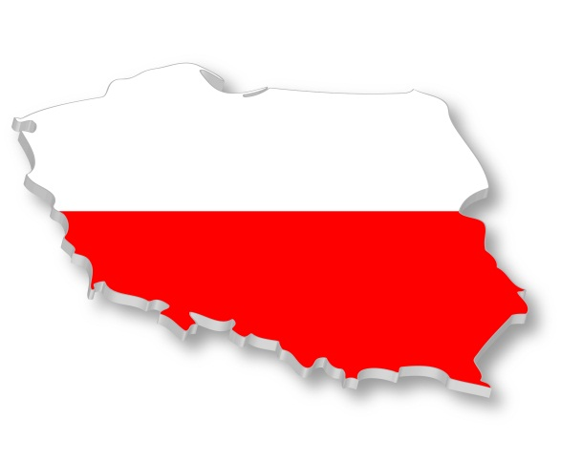
Poland - University of Economy in Bydgoszcz

Basic information
Non-state University of Economy was founded in 1999 and it is situated in Bydgoszcz, the 8th largest city in Poland. Bydgoszcz is located in the northern Poland, 300 kilometres far from capital Warsaw. The city is known as major cultural centre in the country.
Faculty of Health Care and Tourism
Department of Tourism Economy and Geography

Useful links:
Official website of university: http://eurostudies.pl/home.1.html
International office: http://www.cwz.wsg.byd.pl/index.php?id=2

Transport:
- travelling in Poland and abroad: http://www.bilety-autobusowe.com/
- Bydgoszcz city transport: http://www.zdmikp.bydgoszcz.pl/index.php/en
- Bydgoszcz airport is reachable by municipal line bus no. 80
- you can go to Bydgoszcz
  - by plane from Prague with transfer in Warsaw (LOT Polish airlines https://www.lot.com/cz/en/)
  - by train
  - by bus Almabus (http://www.almabus.pl/index-en.html#almabus-4)

Syllabi:
- You can find all the syllabi on this website:
http://www.cwz.wsg.byd.pl/index.php?id=208&submenu=138

The courses:

Study programme for International students 2015/2016 can be found on the following link: http://www.cwz.wsg.byd.pl/index.php?id=208&submenu=138

Academic year
The academic year in University of Economy is divided into 2 parts – SUMMER and WINTER SEMESTER.

Winter semester
The winter semester usually starts at the beginning of October and ends at first or second week in February.

Summer semester
The summer semester begins the third week of February and ends second or third week in June.

Exams:
Exams are held during one week right after the end of semester. If you fail any exam you can pass the exam in two weeks in March (for winter semester) or in two weeks in August (summer semester).

Application and registration:
Firstly you have to apply at your home university. If you are nominated, the application is sent to the University of economy by fax or by post. You have to send these documents:
- Application form, stamped and signed by the Erasmus Programme Co-ordinator of the sending university
- Learning Agreement
- Transcript of records - list of courses completed at home University (English version, confirmed by home Institution)
- Copy of the passport
- 2 photos, passport size
- Accommodation Form
- CV in English
- Health Insurance Policy

Deadline for applications:

15th June for winter semester of the next academic year

15th November for summer semester of the next academic year

Arrival and accommodation
Contact International office about the date and time before you arrival. They will manage someone from Study Buddy assistance programme for foreign students to help you find hotel and discover the city and university.

Accommodation
The international office will provide you accommodation in University hotel. The cost of a single room is 420 PLN (105 EUR) and for double room is 800 PLN – 400 PLN for one person (100 EUR per person). Student has to pay a repayable deposit for a single room 200 PLN (50 EUR) and for a double room 300 PLN (75 EUR). The places in the hostel are limited so be sure to send Accommodation form as soon as possible.
The University’s modern, well-equipped hostel located in the campus (with Internet access), is situated in the city centre near the Old Market Square and the city’s trade and entertainment centre. The Multiplex “Multikino”, the Opera Nova House and Astoria sports hall and swimming pool are all in the vicinity of the University. In the hostel there is “Flinston” student restaurant, where one can have breakfast, lunch or dinner.

Holidays:
1 January New Year’s Day
6 January Epiphany
variable Easter (Easter Sunday, Easter Monday)
1 May Labour Day
3 May Constitution Day
variable Pentecost Sunday (7th Sunday after Easter)
variable Corpus Christi (9th Thursday after Easter)
15 August Assumption of the Blessed Virgin Mary
1 November All Saints’ Day
11 November Independence Day
25 December Christmas Day
26 December Boxing Day

Address
Internatironal Office
Garbary 2 Street
PL – 85229 Bydgoszcz

Don’t forget to pack
- Identity card and
- Health insurance card
- Student card
- Debit / credit card

International contact office

International Affiars Office
e-mail: dsm@byd.pl
website: www.cwz.wsg.byd.pl
phone number: +48 52 567 00 78

Contacts
Director of International Affairs Office
Patryk Antonik
e-mail: patryk.antonik@byd.pl Tel.: + 48 52 567 00 78

Erasmus Coordinator
Malgorzata Adamska
e-mail: malgorzata.adamska@byd.pl Tel.: +48 52 567 00 29

